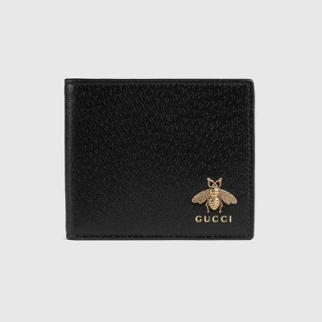

Animalier leather wallet

PRODUCT DETAILS

**Part of the Animalier collection, the leather wallet features the distinctive metal bee**

**detail. The bee is an archival code first introduced in Gucci ready-to-wear in the 1970s.**

**Antique gold-toned hardware • Metal bee • Gucci logo**

**• Eight card slots and two bill compartments • Made in Italy**